**ELECTIVE 3**

Midterm Exam

**Image Processing in Octave**

|  |
| --- |
|  |

Score

*Submitted by:*

**Fabellar, Mark Tristan R.**

**Tuesday 6:00PM-7:30PM / BS CPE 4-2**

*Date Submitted*

**24-11-2022**

*Submitted to:*

**Engr. Maria Rizette H. Sayo**

Methodology

1. Importing, Displaying, and Converting Images
2. Using the Editor of Octave, create a program that will load and display parrots.jpg
3. Examine the size of the parrots by typing whos to find out the size of the image that you have read in
4. Convert the class uint8 color image parrots to a gray scale image, and display the full intensity range gray-scale image using the imshow command
5. Covert the true color image to a gray-scale image
6. Save the program to this format parrots.m
7. Display of Color Images
8. Open the image file nature.jpg from the source folder
9. Read in the file nature.jpg and display it on the screen as a reference image How large an image is created when we use the RGB representation compared to a gray-scale image conversion of it?
10. Assign an image color that intensifies red, green, and blue and display each image in one window
11. Convert each image file extension to png
12. Save the program as nature.jpg

*Note: Take a screen shot of the output display of the converted images and do not forget to write your Octave code to this manuscript*

**PROBLEM I**

Importing, Displaying, and Converting Images

1. Using the Editor of Octave, create a program that will load and display parrots.jpg
2. Examine the size of the parrots by typing whos to find out the size of the image that you have read in
3. Convert the class uint8 color image parrots to a gray scale image, and display the full intensity range gray-scale image using the imshow command
4. Covert the true color image to a gray-scale image
5. Save the program to this format parrots.m
6. **Source Code of the Program**

# NAME**:** Fabellar**,** Mark Tristan R**.**

# COURSE **&** SECTION**:** BS CPE 4**-**2

# DESCRIPTION**:** Midterm Exam **-** PROBLEM 1

clc**;**

clf**;**

clear all**;**

close all**;**

pkg load image**;**

# Viewing the Image **(**parrots**.**jpg**)**

parrot **=** imread**(**'C:\Users\Ron\Desktop\FabellarMarkTristan-CPEN111-Midterm\parrots.jpg'**);**

# Show Output

figure**(**1**),** imshow**(**parrot**),**title**(**'RGB'**);**

# Viewing Details of the Image

whos parrot**;**

# Converting unit8 Image to GRAY SCALE

unit8_parrot**=**imagesc**(**parrot**,** **[**0**,** 255**]);** colormap**(**gray**);**

# Show Output

figure**(**2**),** imshow**(**unit8_parrot**),**title**(**'Unit8 GRAY SCALE'**);**

# Viewing Details of the Image

whos unit8_parrot**;**

# Converting RGB to GRAY SCALE

grayparrot **=** rgb2gray**(**parrot**);**

# Show Output

figure**(**3**),** imshow**(**grayparrot**),**title**(**'GRAY SCALE'**);**

1. **Output of the Program**

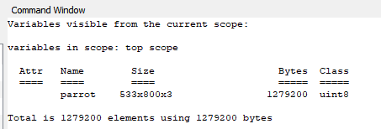

*Details of the Original Image*

The size of the original image (parrots.jpg) is 1279200 Bytes.

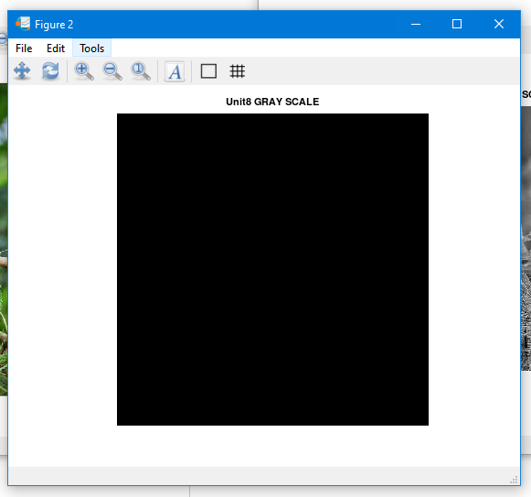

*Gray Scaled Unit8 Version of the Image*

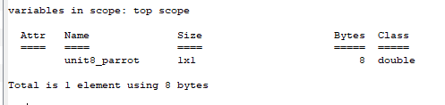

*Details of the Unit8 Image*

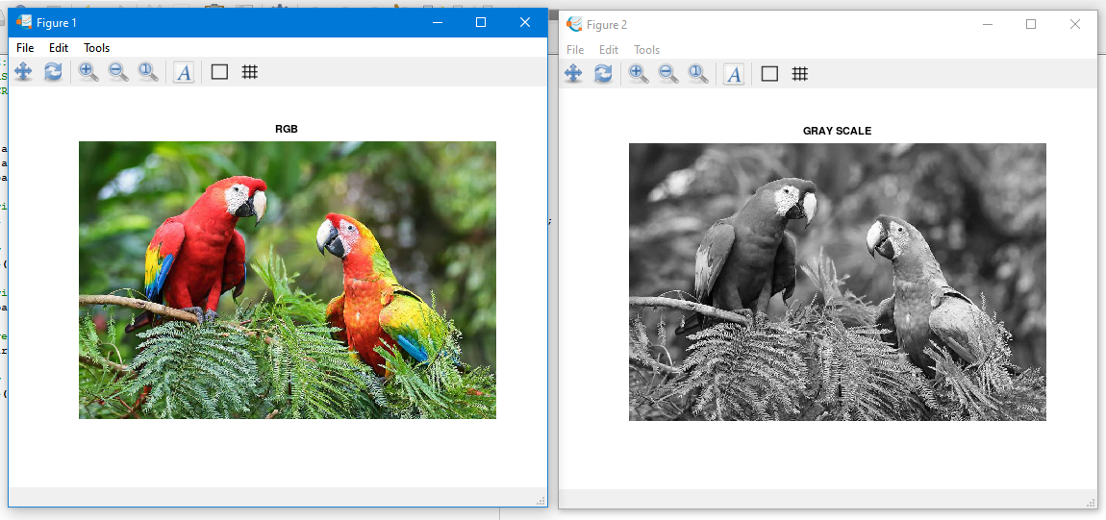

*RGB to Gray Scale Conversion*

**PROBLEM II**

Display of Color Images

1. Open the image file nature.jpg from the source folder
2. Read in the file nature.jpg and display it on the screen as a reference image How large an image is created when we use the RGB representation compared to a gray-scale image conversion of it?
3. Assign an image color that intensifies red, green, and blue and display each image in one window
4. Convert each image file extension to png
5. Save the program as nature.jpg
6. **Source Code of the Program**

# NAME**:** Fabellar**,** Mark Tristan R**.**

# COURSE **&** SECTION**:** BS CPE 4**-**2

# DESCRIPTION**:** Midterm Exam **-** PROBLEM 2

clc**;**

clf**;**

clear all**;**

close all**;**

pkg load image**;**

# Viewing the Image **(**nature**.**jpg**)**

nature **=** imread**(**'C:\Users\Ron\Desktop\FabellarMarkTristan-CPEN111-Midterm\nature.jpg'**);**

# Show Output

figure**(**1**),** imshow**(**nature**),**title**(**'RGB'**);**

# Viewing Details of the Image

whos nature**;**

# Converting RGB to GRAY SCALE

graynature **=** rgb2gray**(**nature**);**

# Show Output

figure**(**2**),** imshow**(**graynature**),**title**(**'GRAY SCALE'**);**

# Viewing Details of the Image

whos graynature**;**

# Image to Red

rednature**=**nature**;**

rednature**(:,:,**2**)=**0**;**

rednature**(:,:,**3**)=**0**;**

figure**(**3**),** imshow**(**rednature**),**title**(**'RED'**);**

# Image to Green

greennature**=**nature**;**

greennature**(:,:,**1**)=**0**;**

greennature**(:,:,**3**)=**0**;**

figure**(**4**),** imshow**(**greennature**),**title**(**'GREEN'**);**

# Image to Blue

bluenature**=**nature**;**

bluenature**(:,:,**1**)=**0**;**

bluenature**(:,:,**2**)=**0**;**

figure**(**5**),** imshow**(**bluenature**),**title**(**'BLUE'**);**

% Rewriting the Image (Red, Blue, Green)

imwrite**(**rednature**,**'C:\Users\Ron\Desktop\FabellarMarkTristan-CPEN111-Midterm\nature_red.png'**);**

imwrite**(**greennature**,**'C:\Users\Ron\Desktop\FabellarMarkTristan-CPEN111-Midterm\nature_green.png'**);**

imwrite**(**bluenature**,**'C:\Users\Ron\Desktop\FabellarMarkTristan-CPEN111-Midterm\nature_blue.png'**);**

1. **Output of the Program**

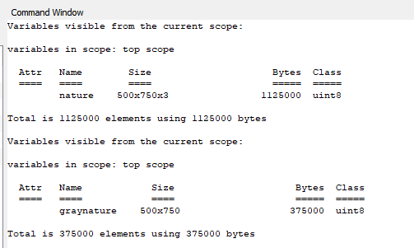

*Difference Between the Details of RGB and Gray Scale Image*

The size in bytes of the original version of image which is RGB is relatively higher in compared to the gray-scaled version. The RGB is three times bigger considering that the gray-scaled size is 375000 Bytes while the RGB is 1125000 Bytes.

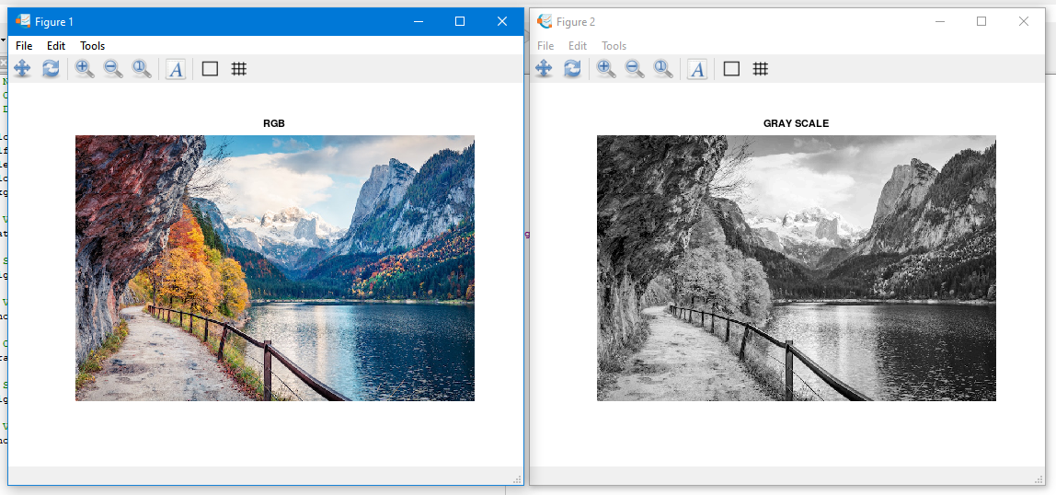

*RGB to Gray Scale Conversion*

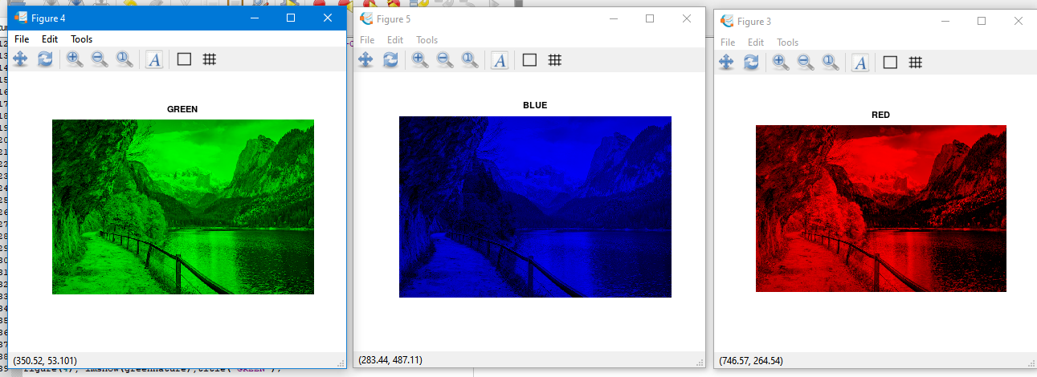

*Intensifying the Color Red, Blue, and Green*

Conclusion

There are a lot of mediums that can be used in order to manipulate a given image. However, not all mediums are as detailed as the Octave. The processes in creating a program in order to do something in an image is quite complicated but all of these are useful when working with projects where it will be utilized the most.

*Note: To view more about the input of the student. Visit* <https://github.com/Tristaaaan/FabellarMarkTristan-CPEN111-Midterm.git>

Rubrics in Grading the Midterm Exam

|  |  |  |  |  |
| --- | --- | --- | --- | --- |
|  | A – Excellent | B – Good | C – Fair | D – Needs Improvement |
| Specifications | The Program works and meets all of the specifications | The program works and produces the correct results and displays them correctly. It also meets the most of the other specifications | The program produces correct results but does not display them correctly | The program is producing incorrect results |
| Readability | The code is exceptionally well organized and very easy to follow | The code is fairly easy to read | The code is readable only by someone who knows what it is supposed to be doing | The code is poorly organized and very difficult to read. |
| Reusability | The code could be reused as a whole or each routine could be reused | Most of the code could be reused in other programs | Some parts of the code could be reused in other programs | The code is not organized for reusability |
| Documentation | The documentation is well written and clearly explains what the code is accomplishing and how | The documentation consists of embedded comment and some simple header documentation that is somewhat useful | The documentation is simply comments embedded in the code with some simple header comments separating routines | The documentation is simply comments embedded in the code and does not help the reader understand the codes |
| Efficiency | The code is extremely efficient without sacrificing readability and understanding. | The code is fairly efficient without sacrificing readability and understanding | The code is brute force and unnecessarily long | The code is huge and appears to be patched together |
| TOTAL |  | | | |